System Design

Jorgo Qendro

Southern New Hampshire University

CS-255: System Analysis and Design

Professor Trajkovski

October 18th, 2024

# CS 255 System Design Document

## UML Diagrams

### UML Use Case Diagram

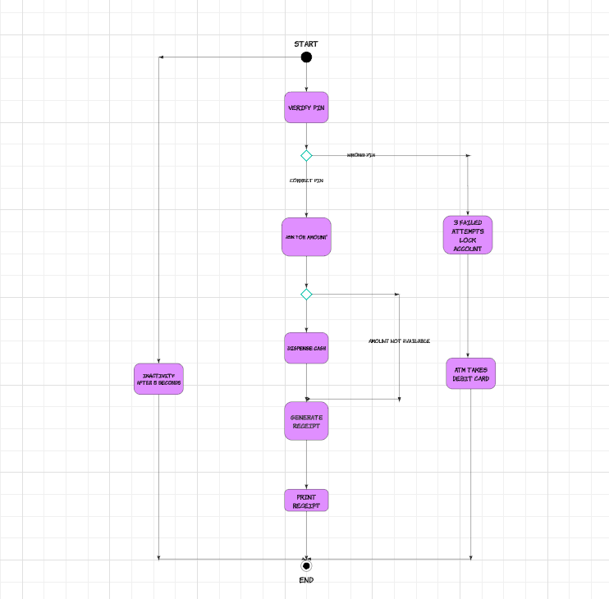

### UML Activity Diagrams

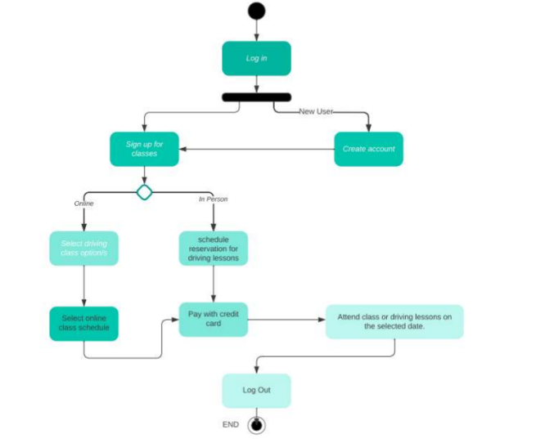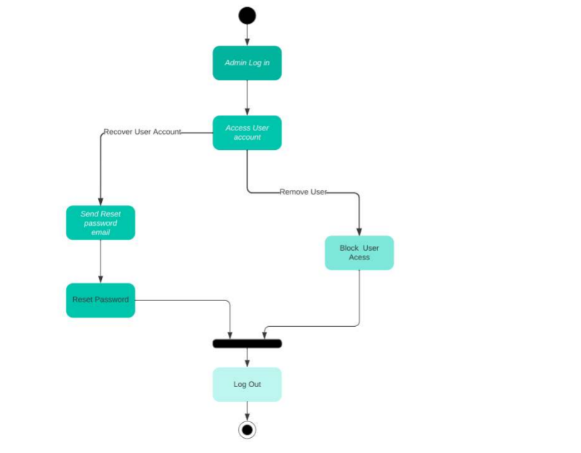

### UML Sequence Diagram

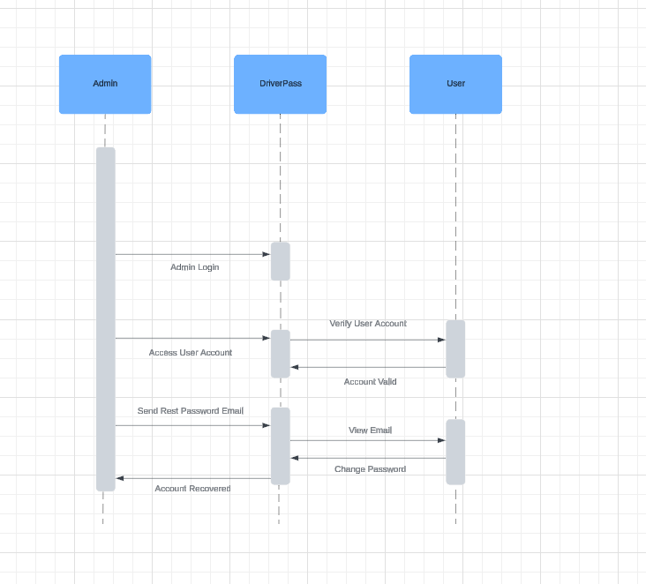

### UML Class Diagram

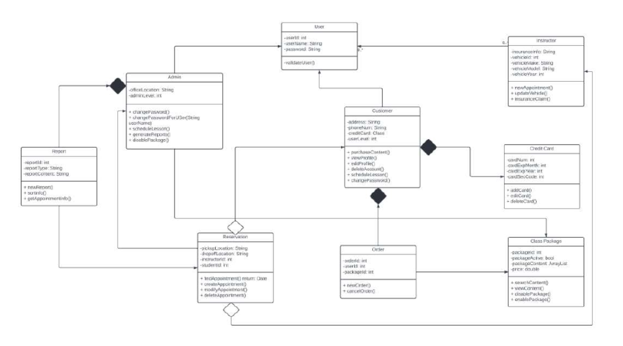

## Technical Requirements

### Technical Specifications

**Hardware Needs:**

* A dedicated server for hosting the system.
* A stable and high-speed internet connection.
* Sufficient storage capacity to manage both the database and website content.
* Access to the website through a computer or mobile device for end-users.
* A firewall to protect the system’s open ports.

**Software Needs:**

* Recommended use of Windows Server for its proven reliability.
* SQL Server (most stable version suggested) for managing the database.
* Backup software to regularly save both the website and database data.
* A web server, such as Apache, to host the site.
* Security software to safeguard against malware and other cyber threats.

**Geographic Considerations:**

* Ensuring the site remains accessible within the United States.
* Hosting the server and database in a secure data center.
* Locating the server in a geographically central area for enhanced performance and user access.